**Standard Operating Procedure**

**DG Set Operation**



**ODISHA MINING CORPORATION LTD.**

**KODINGAMALI BAUXITE MINE**

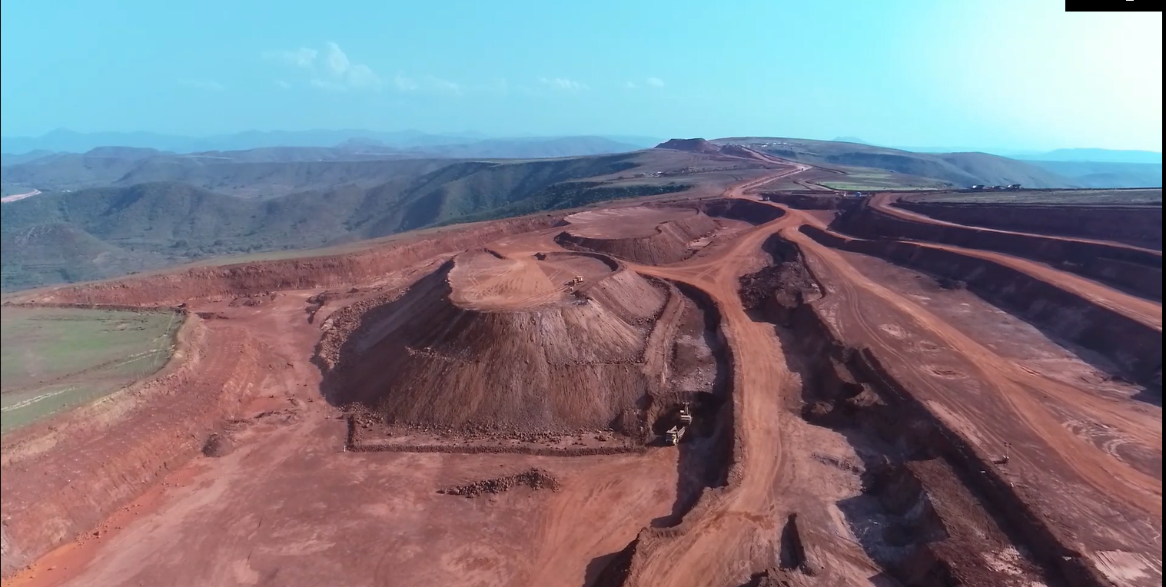

**Authorized By**

1. **PURPOSE:**

To provide the standard operating procedure for Diesel Generator operation set in Kodingamali Bauxite Mine.

1. **SCOPE:**

This procedure is applicable for safe Operation of diesel generator in Kodingamali Bauxite Mine.

1. **RESPONSIBILITY:**

|  |  |  |
| --- | --- | --- |
|  | Diesel generator | D. G. Operator |
|  | D. G. Maintenance | Maintenance Mech. / Ele. Incharge |
|  | Field Operation | Supervisor/Shift Incharge |
|  | Operational Control | Area in-charge |

1. **SAFETY AND HEALTH HAZARDS:**

* Slip/trip/fall.
* Head on Collision.
* Toppling of D G.
* Dust generation during Operation.
* Noise during Operation.
* Vibration during Operation.
* Diesel/ Hydraulic Oil - Inflammable, Fire hazards.
* Acid Batteries- Skin contact can lead to extensive and severe burns and highly toxic.

In order to avoid injuries to personal and damage to machinery, the following precautions are very important.

* Work required PPE i.e. with safety shoes, helmet, dust musk, fluorescent jacket suitable for long distance visibility etc.
* Pre Operation Safety features checklist.
* Regular Checks & Maintenance.
* Use chimney to realize fumes minimum height 5 to 10 mtrs.
* Use 130 DB ear plug/muff.

***Note: Report immediately to Supervisor, Shift Incharge and Safety officer for any incident/accident.***

1. **ENVIRONMENT ASPECT:**

* Dust generation
* Noise Pollution
* Vibration
* Oil Spillage

Preventive measures:

* Regular use blower for dust control.
* Use of Dust Mask/Earplug

Control of leakages

1. **TOOLS:**

All Work required PPEs like Safety Helmet, Safety shoes, Nose mask, Ear Plug, hand gloves & Jacket.

1. **PROCEDURE:**

Experienced persons should be employed for the job. Ensure that persons running the DG are equipped with safety helmet.

**FOR STARTING DIESEL GENERATOR SET IN MANNUAL MODE**

* Check fuel level into the diesel service tank.
* Check battery voltage on the alternator panel. It should be 23 to 26 volt DC.
* Check coolant level into the radiator.
* Start lubricating pump by pushing its “ÖN” button on the breaker panel.
* Release the Red Colour Emergency Push button and reset the DG set by pressing the Reset button. Crank the engine by turning the key to “RUN” position.
* Engine will pick-up and will develop voltage.
* Check voltage between R-Y, Y-B and B-R. It should be 415 to 420 volts.
* Check frequency of supply, It should be 49.5 to 50Hz.
* Now close the DG breaker from the alternator panel.
* Use touch screen to scroll the reading.
* Check various readings of parameters on alternator panel and note it in the DG set operation monitoring record.
* The parameters are: RPM, lube oil pressure, lube oil temperature, water temperature

(in / out ), voltage (RY, YB, BR ), current (R, Y, B,) frequency, KWH, KW, P.F.

**FOR STOPPING DIESEL GENERATOR SET IN MANUAL MODE**

* Check final reading of parameters and note in the DG set log book.
* By pressing open button on the alternator panel release the DG in comer breaker.
* Turn the key of DG set to OFF position.
* Press the red colour Emergency push button.

**FOR STARTING DIESEL GENERATOR SET IN AUTO MODE**

* After the power failure, the engine will start automatically after 30 seconds.
* Check fuel level into the diesel service tank.
* Check coolant level into the radiator.
* Engine will pick-up and will develop voltage.
* Check voltage between R-Y, Y-B and B-R. It should be 415 to 420 volts.
* Check frequency of supply, It should be49.5 to 50 Hz.
* DG breaker will close automatically.
* Use touch screen to scroll the readings.
* The parameters are: RPM, lube oil pressure lube oil temperature, water temperature (in / out), voltage (RY, YB, BR), current (R, Y, B), Frequency, KWH, KW, PF.

**FOR STOPPING DIESEL GENERATOR SET IN AUTO MODE**

* DG set verifies the M.S.E.B. Supply is resumed.
* The DG incomer, bus coupler 1 and 2 breakers will open automatically.
* The breaker of transformer 1 and 2 will close automatically.

**SHUT DOWN:**

* Install the machine in safe place.
* Switch off all apparatus which work on electricity or engine.
* Remove ignition key & lock the cabin.

|  |  |  |  |  |
| --- | --- | --- | --- | --- |
| **PROTOCOL OF DIESEL FILLING** | | | | |
|
| **LOCATION: MYTHRI CAMP DG SHED** | | | | |
| **FREQUENCY OF FILLING** | 2 Time In A Day | | | |
| **TIMING OF FILLING** | Any Time In **A** And **B** Shift | | | |
| **MANDATORY AUTHORITY** | 1.Mahendra Naik (Electrician) | | | |
| 2.Ranjan Ku Jena (Electrician) | | | |
| 3.Kabitra Muduli (Electrician) | | | |
| **MANDATORY PPEs** | 1.Hand Gloves | | | |
| 2.Dust Mask | | | |
| 3.Helmet | | | |
| 4.Refecting Jacket | | | |
| 5.Safety Shoe | | | |
| **PROCEDURE** | 1. Entry Of Loaded Vehicle. ( Diesel Browser ) | | | |
| 2. Authorized Person Accompany | | | |
| 3. Authorized Person-Proper Compliance Safety Protocol, Follow Do & Don't, Safety Devices Of Vehicle. | | | |
| 4. Permission For Loading. |  |  |  |
| 5. Close & Exit. | | | |

|  |  |
| --- | --- |
| **DAILY HOUSEKEEPING PROTOCOL** | |
|
| **Location: Mythri Camp DG Shed** | |
| **Frequency of Cleaning** | 1 times |
| **Timing of Cleaning** | 09 am to 10 am |
| **Authorized Cleaning Crew** | 1. Parama Perpeka (helper) |
| 1. Karunakar Benia (helper) |
| 1. Mahendra Naik (electrician) |
| 1. Ranjan Ku Jena (electrician) |
| 1. Kabitra Muduli (electrician) |
| **Mandatory PPEs** | 1. Hand Gloves |
| 1. Dust Mask |
| 1. Helmet |
| 1. Reflecting Jacket |
| 1. Safety Shoe |
| **Cleaning Procedure** | Follow do and don’ts, types of cleaning: general cleaning and dusting. |
| **Garbage Segregation Procedure** | Dispose in respective dustbins or store house. |
| **Garbage Disposal Procedure** | Dispose dustbin garbage in disposal pit |
| **Miscellaneous Call** | Emergency response during miscellaneous cleaning requirement |